JAVA 8 features:

MAIN Features:

Simplify java programming

Enable functional programming

Write more readable and concise code

Java 1.8 features

1.interface changes:

1.1.default methods

1.2.Static methods

2.Functional interface

Only have one abstract method

Predefined methods

2.predicate @bipredicate

2.2. consumer & bi consumer

2.3 supplier

2.4.Function

3.Lambda Expression

4.Method references & Constructor references

System.out::println

5.stream API

List of employee

Get salary sorting

Whose salary greatger than 1lkah working in hyd location

Optional class – to avoid null pointer exception

Spilterator

String joiner

Collection framework changer

Data &time

Interface:

Only have abstract method not body

Here we are changing anu value in interface should override interface methods

So we are default method

Default methods can be overiden static not because we can with name

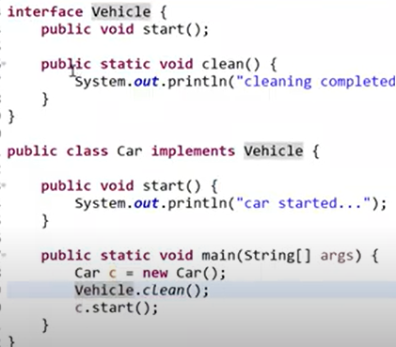

Default :if u want to override the methods of different then we can go for default methods

Static :if u don’t want override

Lambda Expressions:

Here simplify the code

Functional programming:

Store data as form of function and will access outside the class store the reference value

Here lambda is functional programming

What is lambda:  
anynomous function will havnt name,modifier,return type